RESOURCE PERSONS

**Dr. Sachin Sharma**

He is currently working as a Lecturer II/Assistant Professor (above the bar) at National College of Ireland. Prior to this, he worked as an Experienced Researcher at NEC Laboratories Europe. He holds the Doctor of Philosophy (PhD) degree in Computer Science Engineering from Ghent University, Belgium, and the Master of Technology (M. Tech) degree in Computer Applications from Indian Institute of Technology, Delhi, India. During his PhD and Post-PhD experience, he was actively involved in several European and Belgian funded projects: SPARC, OFELIA, CityFlow etc, and led to more than 35 publications in top international journals (such as IEEE Network, IEEE Communications Letters and more) and peer reviewed International conferences. In addition, Sachin's PhD work is lively demonstrated in top venues in networking such as ACM SIGCOMM, IEEE INFOCOM, and IM. Before starting the PhD, Sachin was working as a senior software engineer at Tejas Networks India Limited. His current research interests include the design and evaluation of Software Defined Networks (SDN) and Ad hoc Networks.

**Mr. Sandip Mondal**

He is currently working as Data Architect at CI Investments Inc. in Toronto, Canada. Prior to this, he worked as Hadoop Delivery Lead at ESB, Ireland and as a Data Specialist at Ireland. He has 10 plus years of IT experience specializing in Big Data Analytics (Data Lake), Data Engineering, Data Science, Enterprise Data Warehousing (ETL), Business Intelligence, Data Architecture, Data Governance and Project Management. He holds the Master of Science (M.Sc.) in Data Analytics from National College of Ireland. As a Data Specialist at IBM, he led, defined, designed, developed and implemented enterprise DW & BI projects supporting complex, high-volume, high-dimensionality data from varying sources. He also managed, architect, designed, developed & implemented enterprise-level Data Analytics solutions including requirements analysis, data architecture design, data modelling, solution development & deployment to tackle the Big Data Analytics (Data Lake), Data Warehouse & Data Science needs across ESB using the latest technologies in data exploration, modelling & visualisation covering on-premise & cloud-based deployment.

**Mr. Ishwari Singh Rajput**

He is working as an assistant professor in the department of Information technology at KNIT Sultanpur, India. He is a Researcher and pursuing his PhD from NIT Patna, India in the field of Deep Learning.  He has received M.Tech from Amity University Noida, India in 2014 and B.Tech from UPTU Lucknow, India in 2008. He has approx. 13 Years of Experience as an Academician. His research activity is mainly focused on Sentiment Analysis using Deep Learning and Applications of Sentiment Analysis in Recommendation systems. He has published various research papers in International Journals and international conferences.

**Dr. Mohit Kumar**

He is working as an assistant professor in the department of Information Technology at NIT Jalandhar, India. He has completed his PhD from IIT Roorkee in the field of Cloud/Fog Computing. He has completed M. Tech from ABV-IIITM Gwalior in 2013 and B. Tech from MJP Rohilkhand University Bareilly in 2009. His research activity is mainly focused on energy efficiency; resource provisioning, scheduling, elasticity, load balancing, resource allocation and security in cloud/Fog Computing. He has published more than 20 papers in reputed Journal and international conferences.

**Dr. Amritpal Singh**

He is working as an assistant professor in the department of Computer Science and Engineering at National Institute of Technology, Jalandhar. He has completed his PhD from Thapar Institute of Engineering and Technology, Patiala, Punjab in the field of Probabilistic Data Structures. His primary research interests lie in Machine Learning (ML) and the role of Probabilistic Data Structure (PDS) in various data mining domains. His research focuses on the design, analysis, implementation, and experimental evaluation of machine learning algorithms combined with PDS in streamed data. He has published more than 15 papers in reputed Journals.

**Dr. Arun Chauhan**

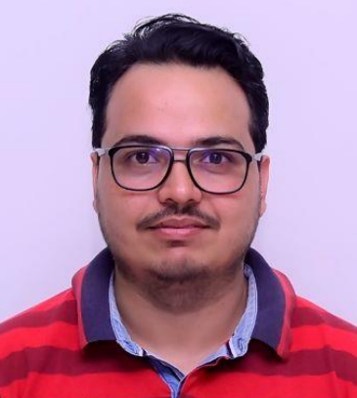He is currently working as an Assistant Professor at the Indian Institute of Information Technology, Dharwad, Karnataka.

Prior to this he has also worked in BITS Pilani and IBM Watson. He holds the Doctor of Philosophy (PhD) degree in Computer Science

Engineering from IIT Roorkee in the field of Prediction of Recommendation of places of visit using microblogs.

He has published many papers in reputed Journal and international conferences.

He also received the Best Paper Award in the International workshop on Machine Learning and Text Analytics. His fields of research

interests include Machine learning and Recommended Systems.

**Dr. Kamal Bhattacharya**

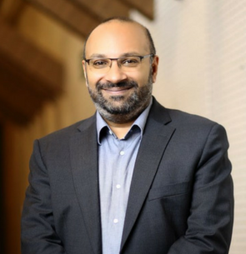Dr. Kamal Bhattacharya is a Professor for Computer Science at IUBH International University in Germany. He is also Co-Founder and CEO of mojo.chat, a startup focused on communication skills development. Kamal spent most of his professional career in

applied R&D across the US, Asia, and Africa. Before his current roles, he served as Chief Innovation Officer at Safaricom and was the inaugural Director and Vice President at IBM Research – Africa. He also served as a commissioner of the Pathways for Prosperity Commission on Technology and Inclusive Development, as Senior Lecturer at MIT Sloan Business School, acting CEO of the iHub in Nairobi, and Country Manager for the International Growth Center in Kenya. Kamal holds a Ph.D. in Theoretical

Physics from Göttingen University in Germany, has published 50+ papers in international scientific journals and conferences, and holds 20 patents.